Mathematical Symbol

🌟 Definition
# Source: AI Source: Provided by: [Data Path: Persons Table -> ID Column: 1, Name_En Column: Motasem Essam] -> From: [ChatGPT] on [5/29/2026]
A mathematical symbol is a special character or sign used in mathematics to represent numbers, operations, relationships, objects, or logical ideas in a short and precise way.
Mathematical symbols are the basic building blocks of mathematical notation and language.

🎯 Purpose of Mathematical Symbols
# Source: AI Source: Provided by: [Data Path: Persons Table -> ID Column: 1, Name_En Column: Motasem Essam] -> From: [ChatGPT] on [5/29/2026]
- To represent mathematical ideas in a compact form
- To simplify writing and calculations
- To avoid long verbal explanations
- To ensure universal understanding in mathematics
- To express relationships and operations clearly

📚 Main Types of Mathematical Symbols

1. Number Symbols
# Source: AI Source: Provided by: [Data Path: Persons Table -> ID Column: 1, Name_En Column: Motasem Essam] -> From: [ChatGPT] on [5/29/2026]
Represent quantities.
Examples:
- 0, 1, 2, 3, …
- π (pi)
- e (Euler’s number)

2. Operation Symbols
# Source: AI Source: Provided by: [Data Path: Persons Table -> ID Column: 1, Name_En Column: Motasem Essam] -> From: [ChatGPT] on [5/29/2026]
Represent mathematical operations.
Examples:

  - (addition)
- − (subtraction)
- × (multiplication)
- ÷ (division)

3. Relation Symbols
# Source: AI Source: Provided by: [Data Path: Persons Table -> ID Column: 1, Name_En Column: Motasem Essam] -> From: [ChatGPT] on [5/29/2026]
Show relationships between values.
Examples:
- = (equal)
- ≠ (not equal)
- < (less than)
- (greater than)
- ≤ (less or equal)
- ≥ (greater or equal)

4. Algebraic Symbols
# Source: AI Source: Provided by: [Data Path: Persons Table -> ID Column: 1, Name_En Column: Motasem Essam] -> From: [ChatGPT] on [5/29/2026]
Represent variables or unknowns.
Examples:
- x, y, z
- a, b, c

5. Set Theory Symbols
# Source: AI Source: Provided by: [Data Path: Persons Table -> ID Column: 1, Name_En Column: Motasem Essam] -> From: [ChatGPT] on [5/29/2026]
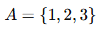
$$A=\{1,2,3\}$$
Other examples:
- ∈ (element of)
- ∉ (not element of)
- ∪ (union)
- ∩ (intersection)

6. Logical Symbols
# Source: AI Source: Provided by: [Data Path: Persons Table -> ID Column: 1, Name_En Column: Motasem Essam] -> From: [ChatGPT] on [5/29/2026]
$$∀, ∃, ⇒, ¬$$
Meaning:
- ∀ = for all
- ∃ = there exists
- ⇒ = implies
- ¬ = not

7. Geometry Symbols
# Source: AI Source: Provided by: [Data Path: Persons Table -> ID Column: 1, Name_En Column: Motasem Essam] -> From: [ChatGPT] on [5/29/2026]
Used in shapes and space.
Examples:
- ∠ (angle)
- ⟂ (perpendicular)
- ∥ (parallel)

🔹 Categories of Common Mathematical Symbols:

1. Arithmetic Operators
# Source: AI Source: Provided by: [Data Path: Persons Table -> ID Column: 1, Name_En Column: Motasem Essam] -> From: [ChatGPT] on [5/29/2026]
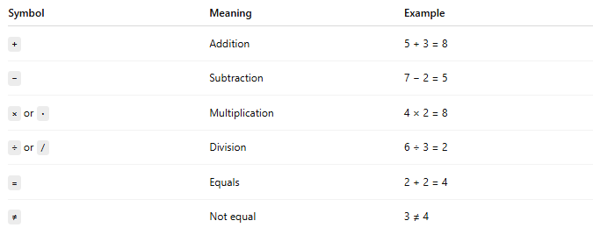
Symbol | Meaning | Example
+ | Addition | 5 + 3 = 8
− | Subtraction | 7 − 2 = 5
× or · | Multiplication | 4 × 2 = 8
÷ or / | Division | 6 ÷ 3 = 2
= | Equals | 2 + 2 = 4
≠ | Not equal | 3 ≠ 4

2. Comparison Symbols
# Source: AI Source: Provided by: [Data Path: Persons Table -> ID Column: 1, Name_En Column: Motasem Essam] -> From: [ChatGPT] on [5/29/2026]
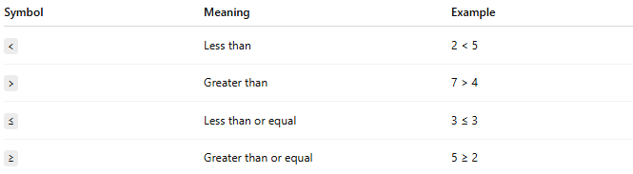

Symbol | Meaning | Example
< | Less than | 2 < 5
> | Greater than | 7 > 4
≤ | Less than or equal | 3 ≤ 3
≥ | Greater than or equal | 5 ≥ 2

3. Set Theory Symbols
# Source: AI Source: Provided by: [Data Path: Persons Table -> ID Column: 1, Name_En Column: Motasem Essam] -> From: [ChatGPT] on [5/29/2026]
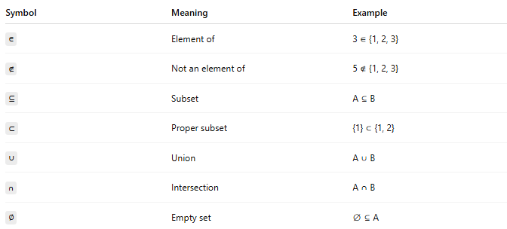
Symbol | Meaning | Example
∈ | Element of | 3 ∈ {1, 2, 3}
∉ | Not an element of | 5 ∉ {1, 2, 3}
⊆ | Subset | A ⊆ B
⊂ | Proper subset | {1} ⊂ {1, 2}
∪ | Union | A ∪ B
∩ | Intersection | A ∩ B
∅ | Empty set | ∅ ⊆ A

4. Logic Symbols
# Source: AI Source: Provided by: [Data Path: Persons Table -> ID Column: 1, Name_En Column: Motasem Essam] -> From: [ChatGPT] on [5/29/2026]
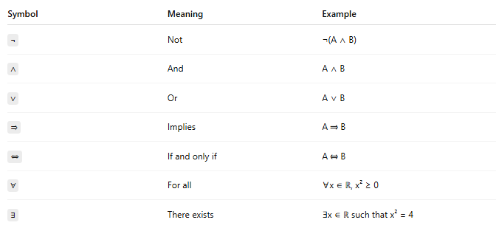
Symbol | Meaning | Example
¬ | Not | ¬(A ∧ B)
∧ | And | A ∧ B
∨ | Or | A ∨ B
⇒ | Implies | A ⇒ B
⇔ | If and only if | A ⇔ B
∀ | For all | ∀x ∈ ℝ, x² ≥ 0
∃ | There exists | ∃x ∈ ℝ such that x² = 4

5. Algebra & Functions
# Source: AI Source: Provided by: [Data Path: Persons Table -> ID Column: 1, Name_En Column: Motasem Essam] -> From: [ChatGPT] on [5/29/2026]
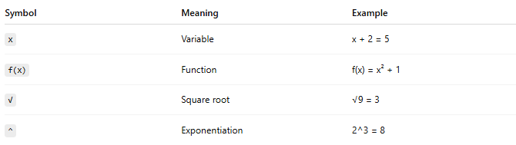

Symbol | Meaning | Example
x | Variable | x + 2 = 5
f(x) | Function | f(x) = x² + 1
√ | Square root | √9 = 3
^ | Exponentiation | 2^3 = 8
` | x | `

6. Calculus Symbols
# Source: AI Source: Provided by: [Data Path: Persons Table -> ID Column: 1, Name_En Column: Motasem Essam] -> From: [ChatGPT] on [5/29/2026]
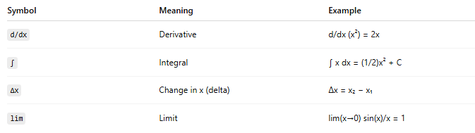
Symbol | Meaning | Example
d/dx | Derivative | d/dx (x²) = 2x
∫ | Integral | ∫ x dx = (1/2)x² + C
∆x | Change in x (delta) | ∆x = x₂ − x₁
lim | Limit | lim(x→0) sin(x)/x = 1

7. Greek Letters (Common in Math)
# Source: AI Source: Provided by: [Data Path: Persons Table -> ID Column: 1, Name_En Column: Motasem Essam] -> From: [ChatGPT] on [5/29/2026]
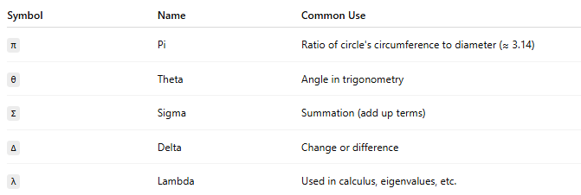
Symbol | Name | Common Use
π | Pi | Ratio of circle's circumference to diameter (≈ 3.14)
θ | Theta | Angle in trigonometry
Σ | Sigma | Summation (add up terms)
Δ | Delta | Change or difference
λ | Lambda | Used in calculus, eigenvalues, etc.

🧩 Examples of Mathematical Symbols in Use

Example 1: Equation
# Source: AI Source: Provided by: [Data Path: Persons Table -> ID Column: 1, Name_En Column: Motasem Essam] -> From: [ChatGPT] on [5/29/2026]
$$x+2=5$$

Example 2: Area Formula
# Source: AI Source: Provided by: [Data Path: Persons Table -> ID Column: 1, Name_En Column: Motasem Essam] -> From: [ChatGPT] on [5/29/2026]
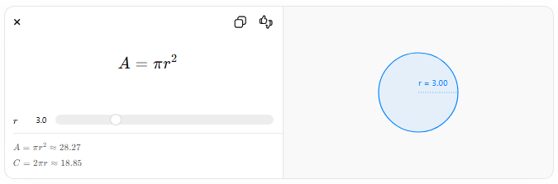
$$A=πr^{2}$$
$$r$$
$$A=πr^{2}≈28.27$$
$$C=2πr≈18.85$$
r = 3.00

Example 3: Logic Statement
# Source: AI Source: Provided by: [Data Path: Persons Table -> ID Column: 1, Name_En Column: Motasem Essam] -> From: [ChatGPT] on [5/29/2026]
$$∀x∈R, x^{2}≥0$$

🔗 Relationship to Other Concepts
# Source: AI Source: Provided by: [Data Path: Persons Table -> ID Column: 1, Name_En Column: Motasem Essam] -> From: [ChatGPT] on [5/29/2026]
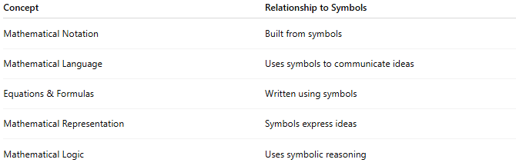
Concept | Relationship to Symbols
Mathematical Notation | Built from symbols
Mathematical Language | Uses symbols to communicate ideas
Equations & Formulas | Written using symbols
Mathematical Representation | Symbols express ideas
Mathematical Logic | Uses symbolic reasoning

📖 Symbol vs Notation vs Language
# Source: AI Source: Provided by: [Data Path: Persons Table -> ID Column: 1, Name_En Column: Motasem Essam] -> From: [ChatGPT] on [5/29/2026]
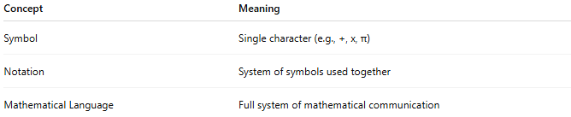
Concept | Meaning
Symbol | Single character (e.g., +, x, π)
Notation | System of symbols used together
Mathematical Language | Full system of mathematical communication

🧠 Simple Analogy
# Source: AI Source: Provided by: [Data Path: Persons Table -> ID Column: 1, Name_En Column: Motasem Essam] -> From: [ChatGPT] on [5/29/2026]
Mathematical symbols are like letters in an alphabet:
- Letters → symbols
- Words → expressions
- Sentences → equations or formulas

🧭 Summary
# Source: AI Source: Provided by: [Data Path: Persons Table -> ID Column: 1, Name_En Column: Motasem Essam] -> From: [ChatGPT] on [5/29/2026]
A mathematical symbol is a special sign used to represent numbers, operations, relationships, and logical ideas in a short and universal way. It is the basic building block of all mathematical writing and communication.

